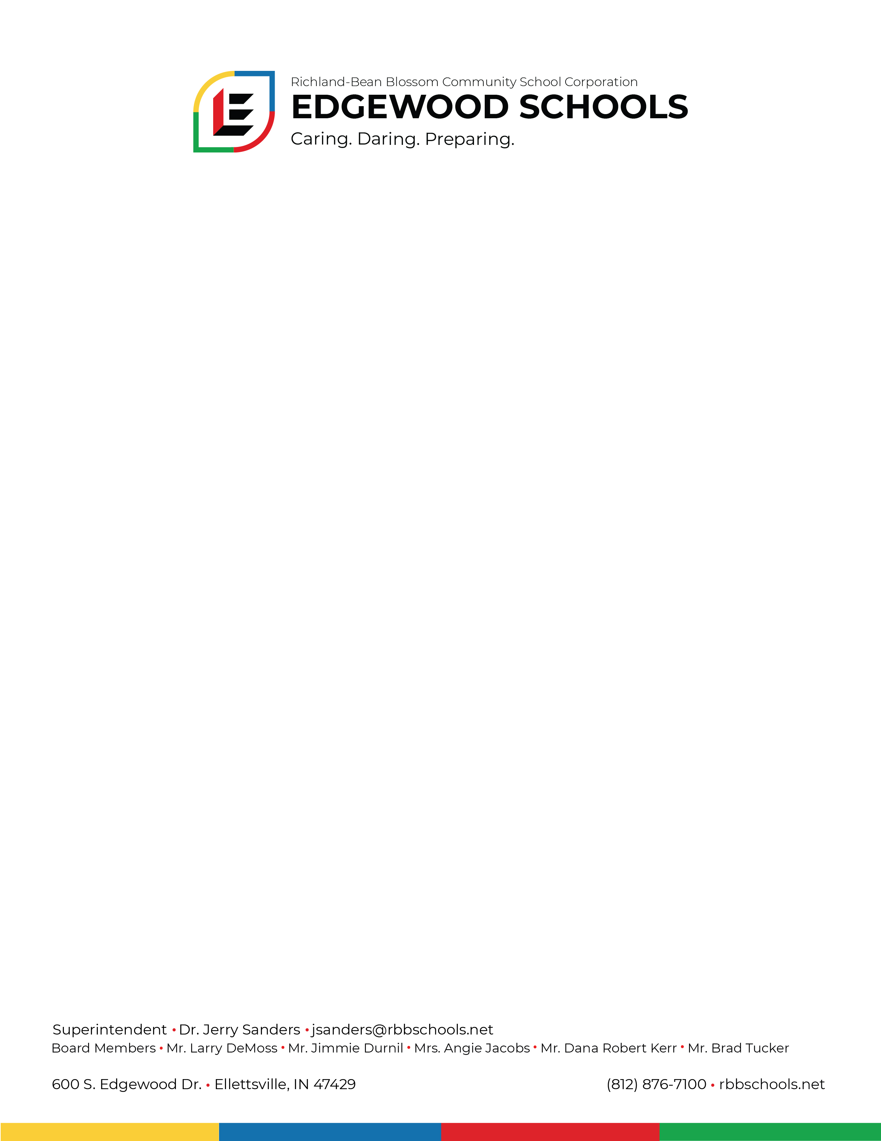

**Notice**

**Location Change** September 22, 2022

The Board of School Trustees of the Richland-Bean Blossom Community School Corporation has changed the location for their November board meeting held on November 21, 2022. The meeting will be held at the Edgewood Junior High School, 851 Edgewood Dr. Ellettsville, Indiana 47429. The meeting will be held in the Multi-purpose room starting at 6:00 p.m.

Dana Robert Kerr, President

Board of School Trustees